# **USING GRID GARAGE TOOLBOX TO BUILD MCAS-S TIP FILES**

By Tom Barrett, NSW OEH, Last updated on 31/01/2018

**How to create or update TIP files**

You will need the following:

* A template TIP file that contains all the fields you want in your TIP files
* Include in this template TIP file all the TIP field information that is common to all grids in your new MCAS-S data pack.
* Information for filling out non-standard TIP fields e.g. custodian of source data etc.

**Step 1.** Create Result Table: Use the [Grid Garage > Geodata > Search] tool to generate a ‘Results Table’ that contains the list of grids you want to generate TIP files for.

*Output=Results Table that contains a list of the geodata that require a new TIP file.*

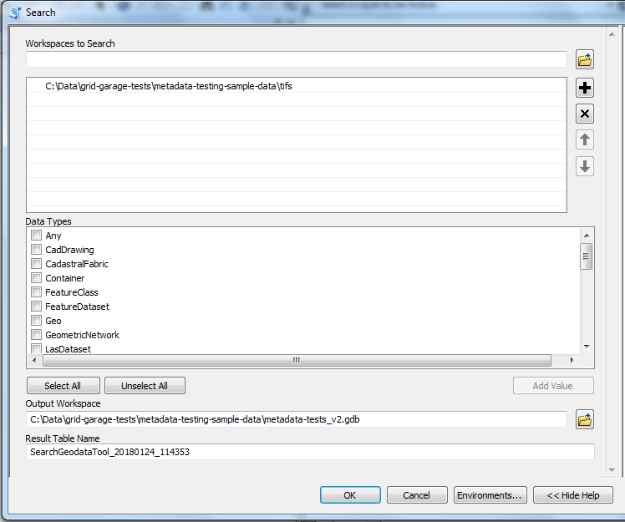

**Step 2.** Create a CSV table in Excel that includes all the fields you need in the final TIP files and include information that is common to all grids in your new MCAS-S data pack.

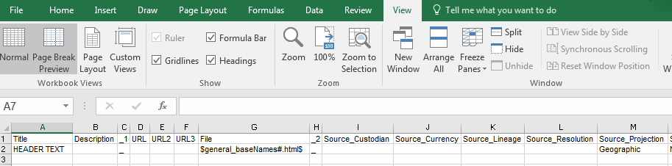

Figure Example of the CSV table created in Excel that contains the template for fields (row one) and default values (row two)

The tip template file needs to be a comma delimited (CSV) file. [See this link](https://cloudstor.aarnet.edu.au/plus/s/7srFY3tltXaGpp1) for an example of a Tip Template file we have used to generate a NSW datapack in OEH. The first row in the CSV Tip template file contains the field names you want to appear in the MCAS-S TIP file. In the second row you can enter text that will be used as the default value for all raster geodata. You can pull values from the *Geodata > Describe* report by bracketing the field name in the $ symbol, for example ‘$dataset_spatialReference$’ would pull out the spatial reference for each input raster. You can also use the field and add extra text, for example ‘$general_baseName# - from OEH - Predictors used in state-wide vegetation modelling project$’ would add the ‘general_baseName’ (the raster name) before the other text. The example below also shows how you can include the name of a field in the raster attribute table in the TIP metadata files using the following format ‘$table_field:*ColNo*$’ where ‘*ColNo’* is the column number in the table for the field you want to copy into the TIP file.

|  |  |
| --- | --- |
| CategoryValue | CategoryLabel |
| $table_fields:2$ | $table_fields:3$ |

**Step 3.** Use the [Grid Garage > Metadata > Create Tips Table] tool to generate a table that contains a column for each of the template TIP fields.

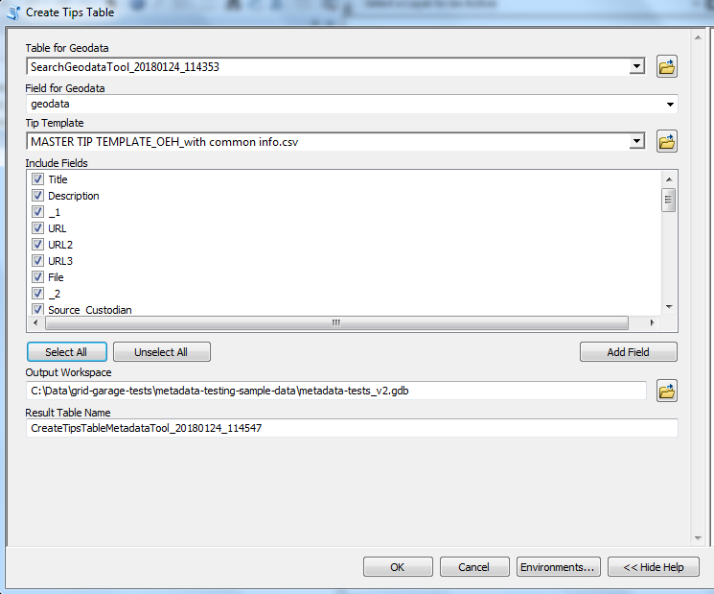

*Input=Output table from Step 1. And Step 2. . SearchGeodataTool_data&time and MASTER TIP TEMPLATE_OEH_with common info.csv.*

*Output=Master TIP file containing the full list of TIP fields with all information that is common to all data layers already filled in (‘CreateTipsTableMetadataTool_date&time’).*



Figure 2 Example of the output table

**Step 4.** Edit the ‘*meta_createtips01_date&time*’ table to fill in empty fields.



Figure Example of manually filling in empty fields in the ‘meta_reatetips01’ table.

**Step 5.** Use the [Grid Garage > Metadata > Export Tips] tool to build the TIP files from the data in the ‘*CreateTipsTableMetadataTool_date_time*’ table.

Appendix 1 – Custom TIP template used by NSW OEH

|  |  |
| --- | --- |
| **Field in TIP file** | **Description** |
| HEADER TEXT | This is the text that appears when you place your mouse over the layer in the MCAS-S display window. |
| Description: | More detailed description, or summary, of the data. |
| _1 | _ (Section divider) |
| URL: | URL link to metadata or other sources of information about the data. |
| URL2: | URL link to metadata or other sources of information about the data. |
| URL3: | URL link to metadata or other sources of information about the data. |
| File: | Link to a file. Enter the name of any file (e.g. Word or PDF document) that has been saved into the folder where the data is stored. So, for example, if there is no URL link available for the data then you can create your own metadata file. |
| _2 | _ (Section divider) |
| Source_Custodian: | Custodian of the source data (used to generate MCAS-S raster grid). |
| Source_Currency: | Currency of the source data (used to generate MCAS-S raster grid). |
| Source_Lineage: | Lineage, or description of how the data was generated, of the source data (used to generate MCAS-S raster grid). |
| Source_Resolution: | Resolution of the source data (used to generate MCAS-S raster grid). |
| Source_Projection: | Projection of the source data (used to generate MCAS-S raster grid). |
| Source_Extent_Region: | Named regional extent of the source data (used to generate MCAS-S raster grid). Eg. Australia, NSW, Western Local Land Services etc. |
| Source_Extent_Coordinates: | Extent described by coordinates of the source data (used to generate MCAS-S raster grid). |
| Source_Data_Format: | Type of format of the source data (used to generate MCAS-S raster grid). E.g. ‘raster grid’, ‘Vector polygon’ etc.. |
| _3 | _ (Section divider) |
| MCAS-S_Currency: | When the data was imported into MCAS-S. |
| MCAS-S_Lineage: | Description of how the source data was processed and imported into the MCAS-S data pack. |
| MCAS-S_Resolution: | Resolution of data layer in MCAS-S data pack, e.g. 100m, 50m etc. To automatically pull this value out use the following notation: **$raster_band_meanCellWidth$** |
| MCAS-S_Projection: | Projection of data layer in MCAS-S data pack. To automatically pull this value out use the following notation: **$dataset_spatialReference$** |
| MCAS-S_Extent_Region: | Named regional extent of data layer in MCAS-S data pack, e.g. Australia, NSW, Western Local Land Services etc. |
| MCAS-S_Extent_Coordinates: | Extent described by coordinates of the data layer in MCAS-S data pack. To automatically pull this value out use the following notation: **$dataset_extent$** |
| MCAS_S_Data_Format: | Type of format of the data layer in MCAS-S data pack (used to generate MCAS-S raster grid). E.g. ‘raster grid’, ‘Vector polygon’ etc. To automatically pull this value out use the following notation: **$general_dataType$** |
| MCAS-S_Data_Type: | Data or file type for data in MCAS-S data pack. To automatically pull this value out use the following notation: **$general_extension$** |
| _4 | _ (Section divider) |
| MCAS-S_Units: | What are the units e.g. ‘mm of annual rainfall’, ‘degrees Celsius’ for temperature etc. |
| MCAS-S_Units_Ranking: | For continuous data - What is the relativity of the values, e.g. high values represent higher rainfall, or, higher pH value equate to more alkaline (less acidic) soil. |
| MCAS-S_Contact_Organization: | Contact organisation for the person who built the MCAS-S data pack. |
| MCAS-S_Contact_Name: | Contact name for the person who built the MCAS-S data pack. |
| MCAS-S_Contact_e-mail | Contact email for the person who built the MCAS-S data pack. |
| _5 | _ (Section divider) |
| CategoryValue | This identifies the main ID or KEY field for categorical data that stores the category labels in a field in the *layer.tif.vat.dbf* file. To automatically pull this value out use the following notation: **$table_field:*ColNo*$** where ‘*ColNo’* is the column number in the table for the field you want to copy into the TIP file. |
| CategoryLabel | This identifies label field for categorical data that stores the category labels in a field in the *layer.tif.vat.dbf* file. To automatically pull this value out use the following notation: **$table_field:*ColNo*$** where ‘*ColNo’* is the column number in the table for the field you want to copy into the TIP file. |